Ems application and arzoo01 application run on nginx with pipeline ;

First we install to the Jenkins,
On git bash
Open the Jenkins your ip address and port number,

Create the new project ;
All ready I created project,
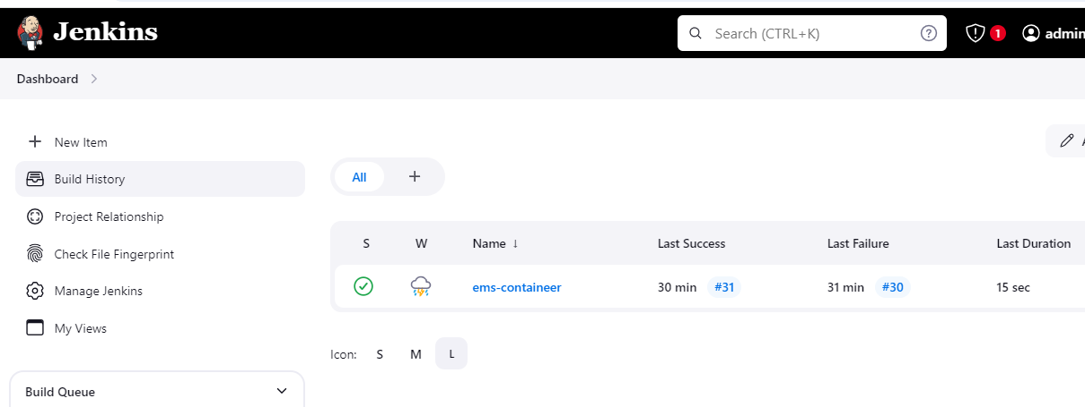

Go to the manage Jenkins
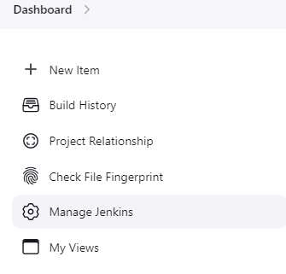
Then go credentials add the git hub credentials,
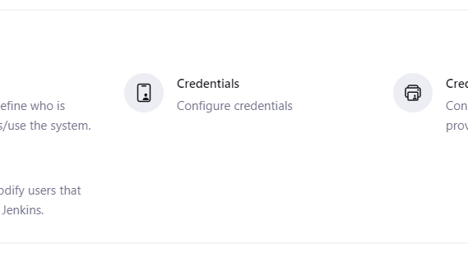
Adding credentials,

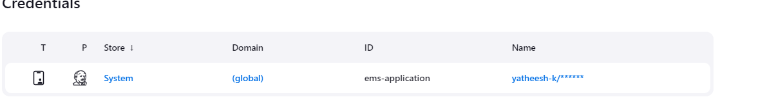

Click on the project then select to the configure option,
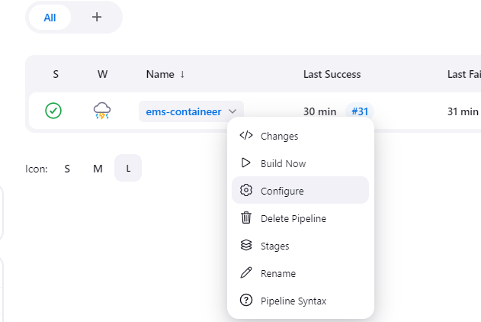

Heare give to the description name,
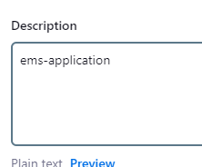

Select the pipeline script,
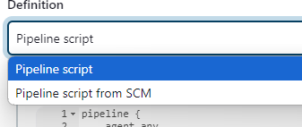

Then write the code
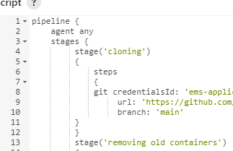

Full code

pipeline {
agent any
stages {
stage('cloning')
{
steps
{
git credentialsId: 'ems-application',
url: 'https://github.com/yatheesh-k/ems-application.git',
branch: 'main'
}
}
stage('removing old containers')
{
steps
{
script{
sh 'docker compose -f /var/lib/jenkins/workspace/ems-containeer/docker-compose.yml down '
}
}
}
stage('building images')
{
steps
{
script{
sh 'docker compose -f /var/lib/jenkins/workspace/ems-containeer/docker-compose.yml build '
}
}
}
stage('new containers')
{
steps
{
script{
sh 'docker compose -f /var/lib/jenkins/workspace/ems-containeer/docker-compose.yml up -d'
}
}
}
}
}

Then save script,

Now run the build,
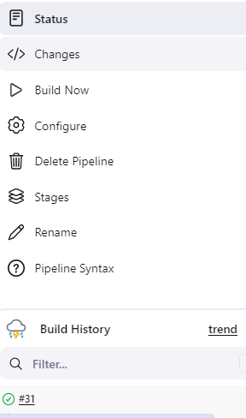

Heare check the code wrong or right,
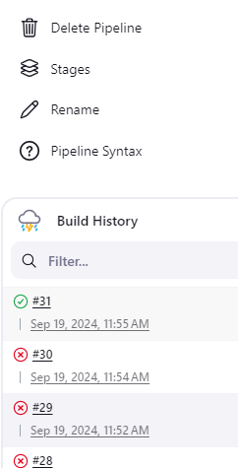

Heare check the where your code was wrong
